Steps to update /var/www/ww-site/winter-winn:

(1) Ensure repository py_dajngo_pg_winn is up to date

(2) log into WINN host machine

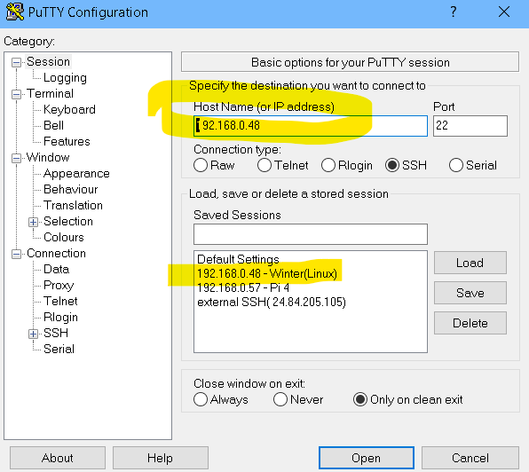

(3) cd /var/www/ww-site

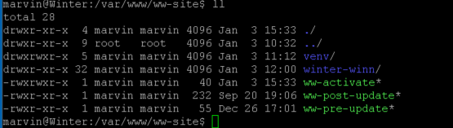

(4) sudo ./ww-pre-update script (OR sudo chown marvin:marvin winter-winn -R )

(5) cd winter-winn

(6) Fetch the repo from remote:

git fetch --all   
git reset --hard origin/master

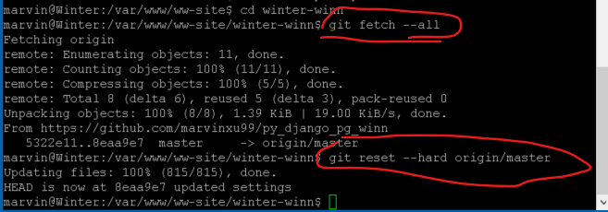

User git remote -v to ensure the correct repo:



(7) source ../venv/bin/activate to activate the VENV

(8) Migrate data as needed:

python3 manage.py makemigrations,

python3 manage.py migrate

(9) python3 manage.py collectstatic

(10) Make compilemessages as needed (if support multiple lanaguages);

Python3 manage.py compilemessages -l zh_Hans

(10) cd .. to /var/www/ww-site

(11) Run the script for post update: sudo ./ww-post-update

(12) sudo systemctl reload apache2

(13) Open winnpysoft.com, and go to iTrac app.

Ensure media files can be uploaded – (Media files on a different machine will be implemented later)

# MEDIA_ROOT is the folder where files uploaded using FileField will go.

if DEBUG:

    MEDIA_URL = '/media/'

    MEDIA_ROOT = os.path.join(BASE_DIR, 'media')

else:

#    MEDIA_URL = 'http://192.168.0.57/media/'

#    MEDIA_ROOT = 'http://192.168.0.57/media/'

    MEDIA_URL = '/media/'

    MEDIA_ROOT = os.path.join(BASE_DIR, 'media'